WHAT IS PostgreSQL
PostgreSQL (often called Postgres) is an open-source, enterprise-grade relational database designed for correctness, reliability, and complex data workloads.
It is widely used by
financial institutions
US SaaS platforms
data analytics systems
geospatial and AI-driven platforms
PostgreSQL is not just a database.
It is a data platform.

2. ADVANTAGES OF POSTGRESQL
PostgreSQL is chosen when systems require:
Strong ACID compliance
Advanced SQL features
Complex joins and analytics
High concurrency
Extensibility
Key strengths in real systems:
It supports advanced indexing (GIN, GiST, BRIN).
It supports JSON/JSONB natively for hybrid SQL + NoSQL workloads.
It supports window functions, CTEs, materialized views, and partial indexes.
It supports row-level locking and MVCC better under heavy concurrency.
It allows custom data types, operators, and extensions.
This is why PostgreSQL dominates fintech, analytics, and SaaS backends.

3. MYSQL VS POSTGRESQL (REAL CLIENT VIEW)
Area | MySQL | PostgreSQL
SQL standard | Limited | Very strong
JSON support | Basic | Native JSONB with indexes
Window functions | Limited | Full support
CTE (WITH) | Basic | Advanced recursive
Concurrency | Moderate | Excellent (MVCC)
Analytics | Weak | Strong
Index types | B-Tree mainly | B-Tree, GIN, GiST, BRIN
Extensibility | Low | Very high
Banking usage | Rare | Very common
MySQL is preferred for
simple CRUD systems
read-heavy websites
PostgreSQL is preferred for
financial systems
reporting platforms
multi-tenant SaaS
data-intensive applications

INSTALL POSTGRESQL USING DOCKER (PRODUCTION STYLE)
Step 1: Pull PostgreSQL Image
docker pull postgres:16
docker images

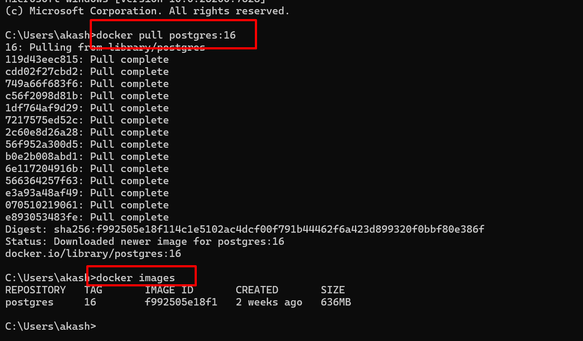

Step 2: Run PostgreSQL Container
docker run -d --name postgres-db -e POSTGRES_USER=admin -e POSTGRES_PASSWORD=admin123 -e POSTGRES_DB=us_ecommerce -p 5432:5432 postgres:16
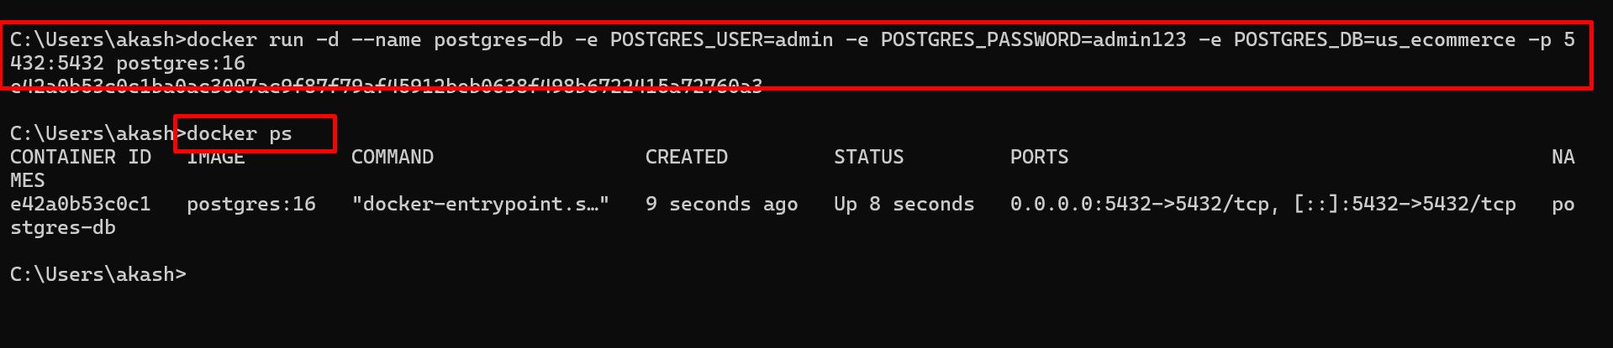

Step 3: Connect to PostgreSQL
docker exec -it postgres-db psql -U admin -d us_ecommerce
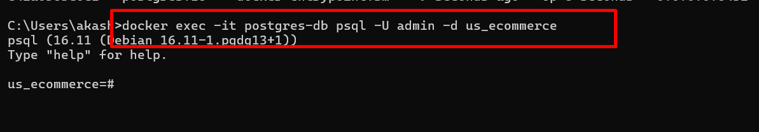

You are now inside PostgreSQL.
Inside PostgreSQL, always run once:
\pset pager off
\x off

BASIC MYSQL VS POSTGRES COMMANDS
Action | MySQL | PostgreSQL
Show DBs | SHOW DATABASES; | \l
Use DB | USE mydb; | \c mydb
Show tables | SHOW TABLES; | \dt
Describe table | DESC users; | \d users

WHAT IS MySQL AND PostgreSQL

MySQL is a fast, simple relational database optimized mainly for CRUD and read-heavy workloads.

PostgreSQL is an enterprise-grade relational database optimized for correctness, analytics, concurrency, and complex queries.

US clients choose between them based on query complexity, not popularity.

2. CORE DIFFERENCE (CLIENT THINKING)

MySQL is chosen when
Data model is simple
Queries are predictable
Mostly SELECT / INSERT
Scaling happens at application level

PostgreSQL is chosen when
Queries are complex
Heavy joins and analytics
Financial correctness matters
Database must do more work

SAME SCHEMA IN BOTH DATABASES
CUSTOMERS TABLE
MySQL
CREATE TABLE customers (
customer_id INT PRIMARY KEY AUTO_INCREMENT,
name VARCHAR(100),
state VARCHAR(50),
created_at DATE
);
PostgreSQL
CREATE TABLE customers (
customer_id BIGSERIAL PRIMARY KEY,
name TEXT,
state TEXT,
created_at DATE
);

ORDERS TABLE
MySQL
CREATE TABLE orders (
order_id BIGINT PRIMARY KEY AUTO_INCREMENT,
customer_id INT,
order_date DATE,
amount DECIMAL(12,2),
status VARCHAR(20)
);
PostgreSQL
CREATE TABLE orders (
order_id BIGSERIAL PRIMARY KEY,
customer_id BIGINT REFERENCES customers(customer_id),
order_date DATE,
amount NUMERIC(12,2),
status TEXT
);

INSERT HUGE RECORDS (REAL PRODUCTION SCALE)
Target:
- Customers → 1,000,000
- Orders → 10,000,000

HUGE INSERT – MySQL (PROCEDURAL)
Customers (1 Million)
DELIMITER $$

CREATE PROCEDURE load_customers()
BEGIN
DECLARE i INT DEFAULT 1;
WHILE i <= 1000000 DO
INSERT INTO customers (name, state, created_at)
VALUES (
CONCAT('John_Doe_', i),
ELT(1 + (i % 5), 'CA','TX','NY','FL','IL'),
CURDATE() - INTERVAL (i % 3650) DAY
);
SET i = i + 1;
END WHILE;
END$$

DELIMITER ;

CALL load_customers();
Orders (10 Million)
DELIMITER $$

CREATE PROCEDURE load_orders()
BEGIN
DECLARE i BIGINT DEFAULT 1;
WHILE i <= 10000000 DO
INSERT INTO orders (customer_id, order_date, amount, status)
VALUES (
1 + (i % 1000000),
CURDATE() - INTERVAL (i % 3000) DAY,
ROUND(50 + RAND()*5000, 2),
ELT(1 + (i % 4), 'CREATED','PAID','SHIPPED','DELIVERED')
);
SET i = i + 1;
END WHILE;
END$$

DELIMITER ;

CALL load_orders();

HUGE INSERT – PostgreSQL (SET-BASED, FAST)
Customers (1 Million)
INSERT INTO customers (name, state, created_at)
SELECT
'John_Doe_' || gs,
(ARRAY['CA','TX','NY','FL','IL'])[1 + (gs % 5)],
CURRENT_DATE - (gs % 3650)
FROM generate_series(1, 1000000) gs;
Orders (10 Million)
INSERT INTO orders (customer_id, order_date, amount, status)
SELECT
1 + (gs % 1000000),
CURRENT_DATE - (gs % 3000),
(50 + RANDOM()*5000)::NUMERIC(12,2),
(ARRAY['CREATED','PAID','SHIPPED','DELIVERED'])[1 + (gs % 4)]
FROM generate_series(1, 10000000) gs;

PostgreSQL completes this much faster than MySQL.

BASIC LEVEL QUERIES (SAME BEHAVIOR)
SELECT * FROM orders WHERE customer_id = 10;
Works similarly in both databases.

INTERMEDIATE LEVEL (PERFORMANCE)
EXPLAIN
MySQL
EXPLAIN SELECT * FROM orders WHERE customer_id = 10;
Shows estimated rows only.
PostgreSQL
EXPLAIN ANALYZE
SELECT * FROM orders WHERE customer_id = 10;
Shows:
- actual execution time
- actual rows
- CPU and I/O usage
This is why DBAs prefer PostgreSQL.

Aggregation
SELECT customer_id, SUM(amount)
FROM orders
GROUP BY customer_id;
PostgreSQL handles parallel aggregation better.

ADVANCED LEVEL (POSTGRESQL DOMINANCE)
Ranking Customers
SELECT customer_id,
SUM(amount) AS total_spent,
RANK() OVER (ORDER BY SUM(amount) DESC)
FROM orders
GROUP BY customer_id;
MySQL requires application logic.

CTE
WITH paid_orders AS (
SELECT * FROM orders WHERE status = 'PAID'
)
SELECT customer_id, SUM(amount)
FROM paid_orders
GROUP BY customer_id;
PostgreSQL optimizes CTEs better.

JSON SUPPORT
MySQL
CREATE TABLE order_events (
id INT AUTO_INCREMENT PRIMARY KEY,
event_data JSON
);
PostgreSQL
CREATE TABLE order_events (
id SERIAL PRIMARY KEY,
event_data JSONB
);

CREATE INDEX idx_event_json
ON order_events
USING GIN (event_data);
PostgreSQL can query JSON at scale.

PARTIAL INDEX (POSTGRES ONLY)
CREATE INDEX idx_paid_orders
ON orders(customer_id)
WHERE status = 'PAID';
Smaller index, faster queries.

MATERIALIZED VIEW (CACHING)
CREATE MATERIALIZED VIEW customer_spend_mv AS
SELECT customer_id, SUM(amount)
FROM orders
GROUP BY customer_id;

REFRESH MATERIALIZED VIEW customer_spend_mv;

PARTITIONING COMPARISON
MySQL:
- Limited index support
- Weaker optimizer
PostgreSQL:
- Declarative partitioning
- Full index support
- Better planner
- Ideal for time-series data

REAL CLIENT DECISION MATRIX
Scenario | MySQL | PostgreSQL
Simple ecommerce | Yes | Overkill
Fintech | No | Yes
Analytics | Weak | Strong
JSON heavy | Limited | Best
Reporting | App-level | DB-level
Scaling complexity | Hard | Easy

